PROJECT REPORT

Title: Bash Scripting Suite for System Maintenance (Assignment 5)
Objective:
To develop a set of Bash scripts to automate daily system maintenance tasks including system backups, software updates, cleanup, and log monitoring.

Introduction
System maintenance is an essential task for ensuring system stability and performance in Linux environments. Manually performing backups, updates, and log monitoring can be time-consuming and error-prone. This project focuses on automating these tasks through Bash scripting.
The suite consists of four main scripts and one library script for logging. Each script handles a specific maintenance task, and they are combined under a menu-driven interface for ease of use.

Project Timeline
Day | Task Completed
Day 1 | Developed script for automated backup
Day 2 |  | Created script to perform system update and cleanup
Day 3 | Built log monitoring script to detect critical system events
Day 4 | Combined all scripts under a menu-driven suite
Day 5 | Tested scripts, improved error handling and logging
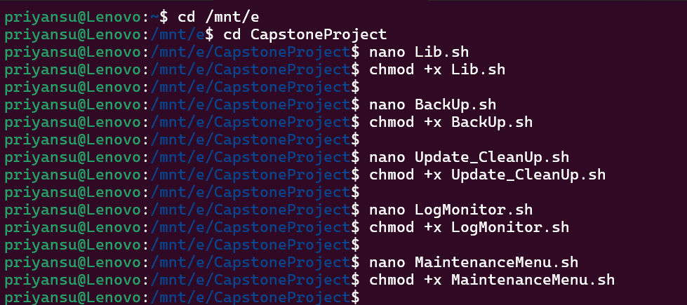

Navigating to the project directory and making all Bash scripts executable.
Lib.sh
#!/bin/bash
ROOT_DIR="$(pwd)"
LOG_FOLDER="$ROOT_DIR/logs"
mkdir -p "$LOG_FOLDER"
LOG_FILE="$LOG_FOLDER/activity.log"
write_log() {
echo "$(date '+%Y-%m-%d %H:%M:%S') :: $1" | tee -a "$LOG_FILE"
}

BackUp.sh
#!/bin/bash
source "$(pwd)/Lib.sh"
read -p "Enter folder to back up (leave blank for current directory): " INPUT
TARGET="${INPUT:-$(pwd)}"

if [[ ! -d "$TARGET" ]]; then
write_log "ERROR: '$TARGET' is not a valid directory."
exit 1
fi
DEST="$ROOT_DIR/backups"
mkdir -p "$DEST"

TIME_TAG=$(date +"%Y%m%d_%H%M%S")
ARCHIVE="Backup_$(basename "$TARGET")_$TIME_TAG.tar.gz"
write_log "Creating backup for $TARGET ..."
if tar -czf "$DEST/$ARCHIVE" -C "$(dirname "$TARGET")" "$(basename "$TARGET")"; then
write_log "Backup saved at: $DEST/$ARCHIVE"
else
write_log "Backup process failed."
Fi
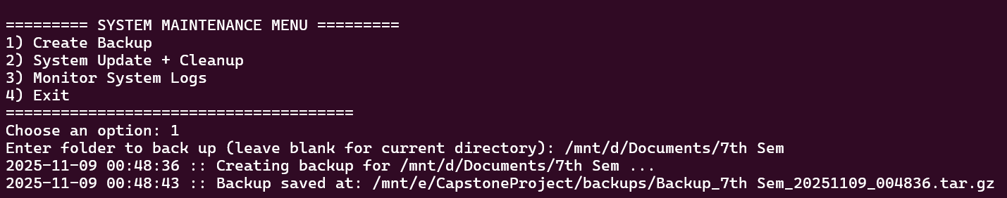
Running the backup script from the maintenance menu and successfully creating a compressed backup archive.
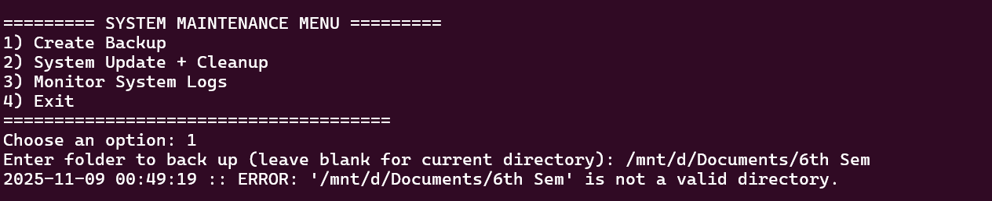

Backup script showing proper error handling when a non-existent directory is entered.
Update_CleanUp.sh
#!/bin/bash

source "$(pwd)/Lib.sh"
write_log "Starting system update..."

if sudo apt update -y && sudo apt upgrade -y; then
write_log "System updated successfully."
else
write_log "System update encountered errors."
fi

write_log "Cleaning unused packages..."
sudo apt autoremove -y >/dev/null 2>&1
sudo apt clean

write_log "Cleanup complete."

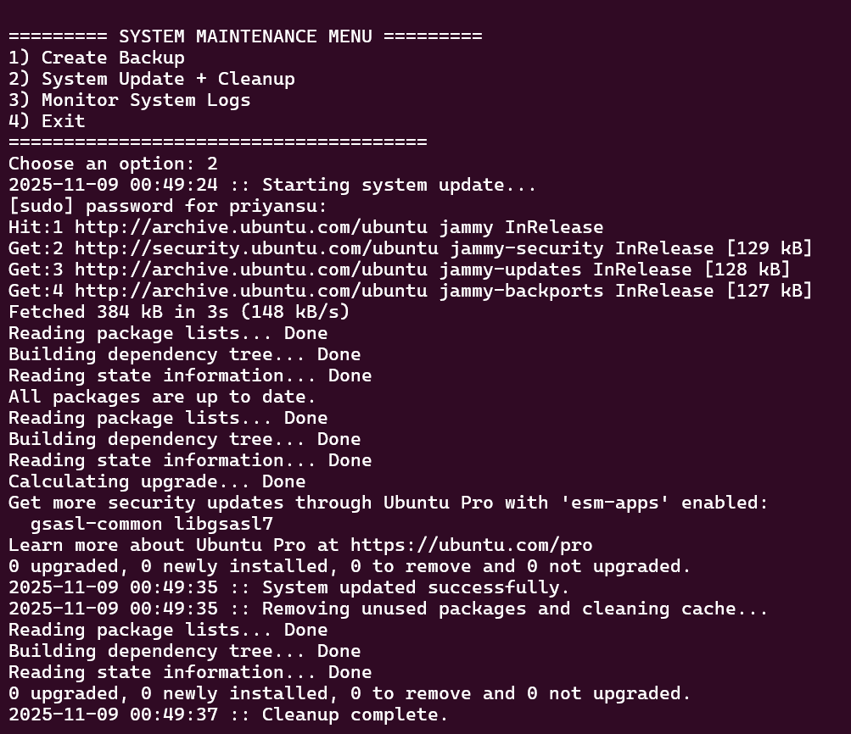

Execution of system update and cleanup script showing the update and package cleanup process.

LogMonitor.sh
#!/bin/bash

source "$(pwd)/Lib.sh"

read -p "Enter log file to monitor (default: /var/log/syslog): " LOG_PATH
LOG_PATH="${LOG_PATH:-/var/log/syslog}"

write_log "Monitoring $LOG_PATH for critical logs..."

tail -f "$LOG_PATH" | grep --line-buffered -Ei "error|fail|warning|critical" | while read LINE
do
write_log "Log Alert: $LINE"
done

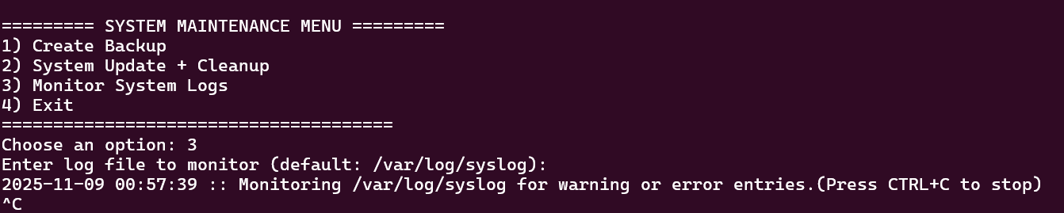
Starting the log monitoring script to watch for critical, warning, and error log entries.

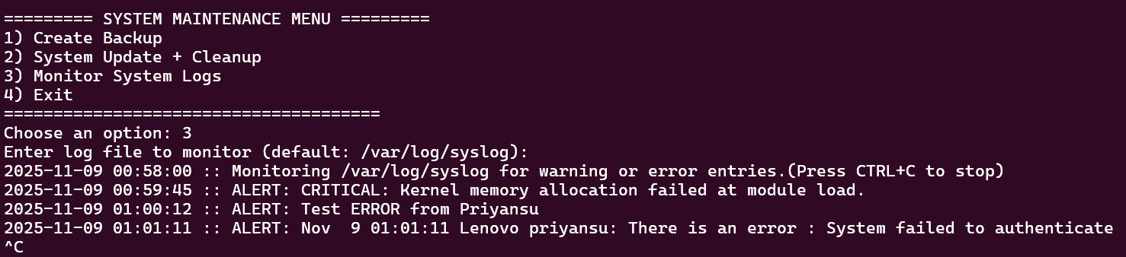
Log monitoring script detecting and logging system error messages in real time.

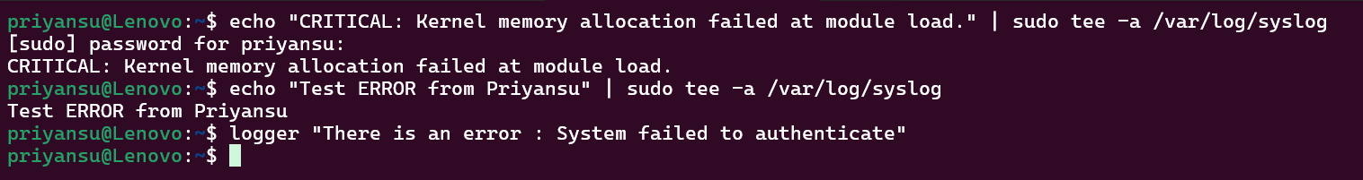
Injecting test log events into /var/log/syslog using echo, tee, and logger commands to verify that the log monitoring script detects and logs errors correctly.

MaintenanceMenu.sh
#!/bin/bash

while true; do
echo ""
echo "========= SYSTEM MAINTENANCE ========="
echo "1) Create Backup"
echo "2) System Update + Cleanup"
echo "3) Monitor System Logs"
echo "4) Exit"
echo "======================================"
read -p "Choose an option: " CHOICE

case "$CHOICE" in
1) ./BackUp.sh ;;
2) ./Update_CleanUp.sh ;;
3) ./LogMonitor.sh ;;
4) echo "Exiting..."; break ;;
*) echo "Invalid option. Try again." ;;
esac
done

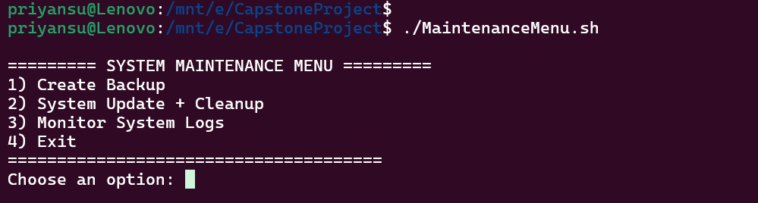

Main maintenance menu displayed, allowing user to choose maintenance tasks through a menu-driven interface.

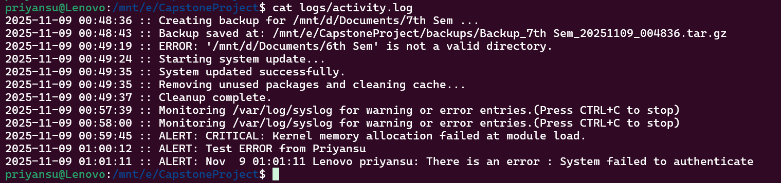

Displaying the activity.log file containing the recorded backup events, errors, updates, and log alerts.

Name: Priyansu Nayak
Reg No: 2241014108
BATCH : 7

